**Installing Cisco AnyConnect VPN**

1. Open any Web Browser and go to <https://vpnciscoaze.jeld-wen.net> (East Coast) or <https://vpncisco.jeld-wen.net> (West Coast).
2. Login with your computer login and password.
3. It will prompt for MFA so complete the MFA challenge.
4. Click on the **Download for Windows** button to download Cisco AnyConnect.
5. You may also click on the “+” next to instructions if you would like to review the installation procedure.
6. Next Install Cisco AnyConnect to your computer and choose all default settings

**Connecting to the VPN**

1. Open Cisco AnyConnect from your programs

Or in the Windows search bar, type “Cisco AnyConnect” and open the app.

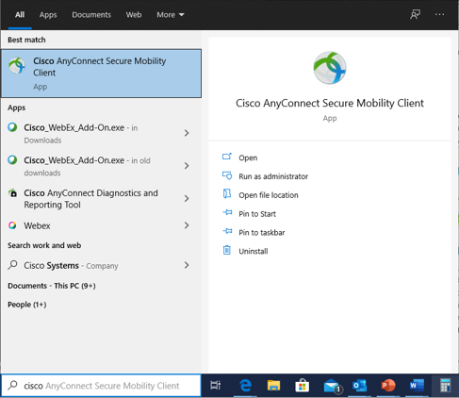

1. First time use only:
   1. Type in the box vpncisco.jeld-wen.net if you are located closer to the west coast or vpnciscoaze.jeld-wen.net if you are located closer to the east coast.

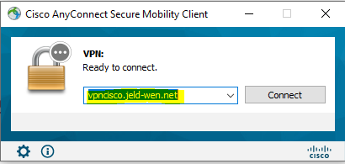

1. You will then be prompted to login with your computer username and password.
2. It will prompt for MFA so complete the MFA challenge.
3. Once connected you may do any work that requires connecting to the VPN.
4. After you are done you can click on “Disconnect” and close Cisco AnyConnect
5. When you connect again it will automatically select the closest VPN to connect to East or West.